Scalene Right Triangle
# Source: AI Source: Provided by: [Data Path: Persons Table -> ID Column: 1, Name_En Column: Motasem Essam] -> From: [ChatGPT] on [7/25/2026]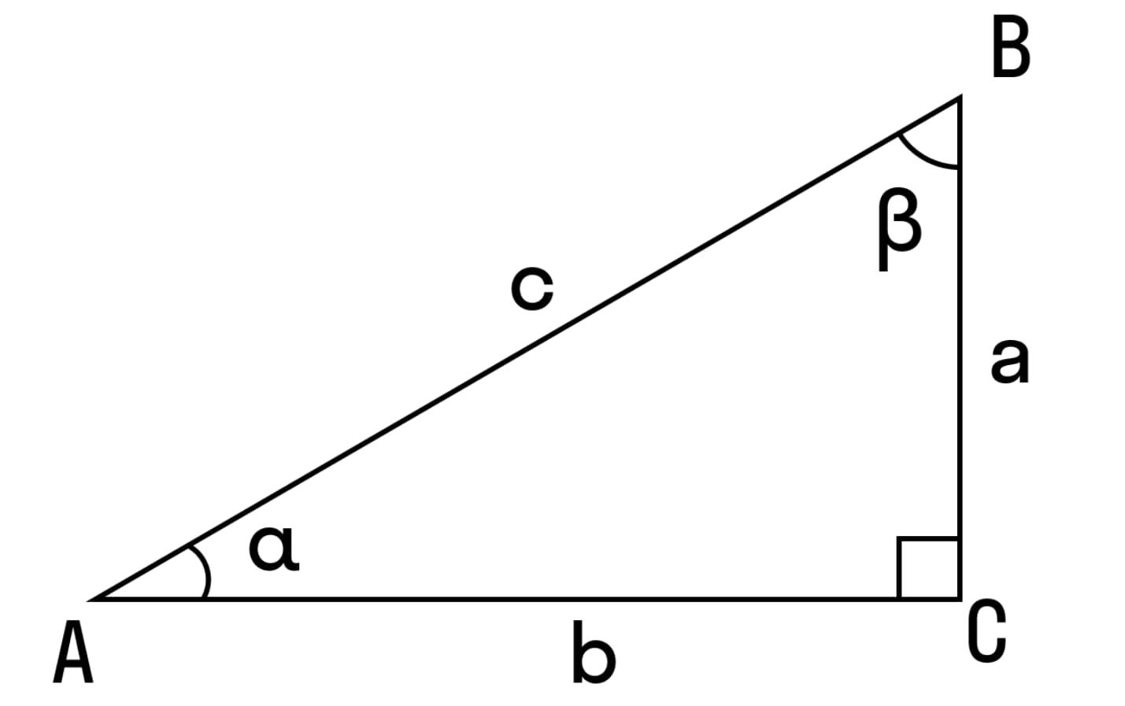
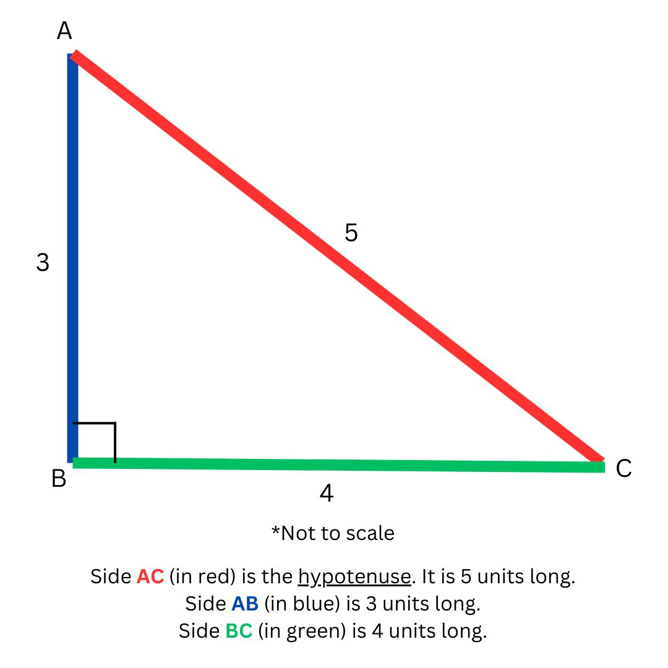
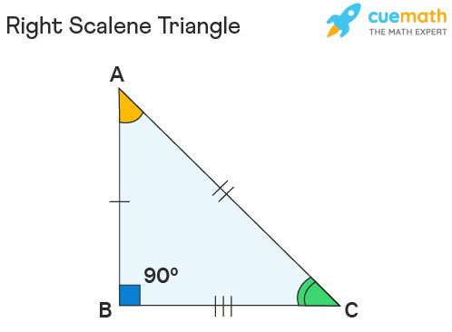
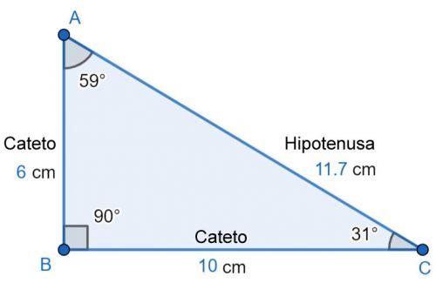
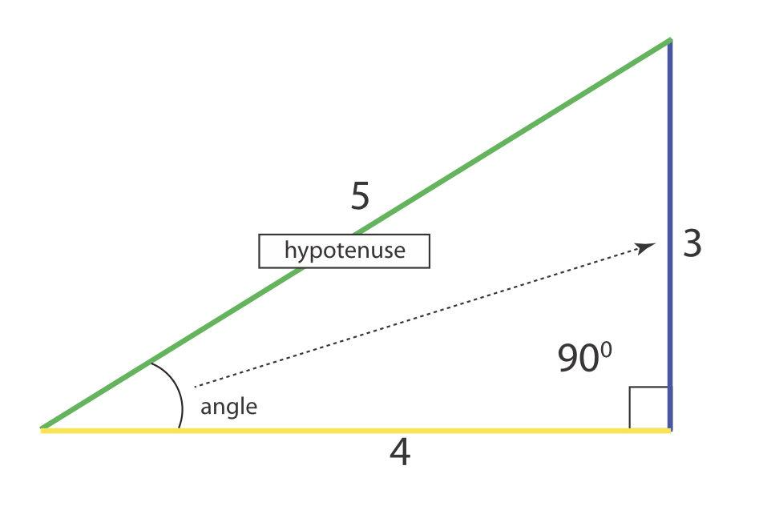

Definition
# Source: AI Source: Provided by: [Data Path: Persons Table -> ID Column: 1, Name_En Column: Motasem Essam] -> From: [ChatGPT] on [7/25/2026]
A Scalene Right Triangle is a triangle that has:
- Three unequal sides, and
- Exactly one right angle, measuring ${90}^{∘}$.
Thus:
$$\boxed{AB≠BC≠CA}$$
and exactly one of its angles is:
$$\boxed{{90}^{∘}}$$
The other two angles are acute and together sum to ${90}^{∘}$.
Therefore:
$$\boxed{∠A+∠B+∠C={180}^{∘}}$$
with, for example,
$$\boxed{∠C={90}^{∘}, ∠A+∠B={90}^{∘}}$$

Classification
# Source: AI Source: Provided by: [Data Path: Persons Table -> ID Column: 1, Name_En Column: Motasem Essam] -> From: [ChatGPT] on [7/25/2026]
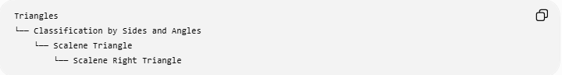
Triangles
└── Classification by Sides and Angles
└── Scalene Triangle
└── Scalene Right Triangle
Or through the two independent classifications:
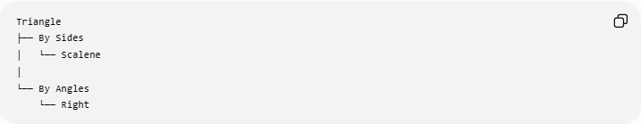
Triangle
├── By Sides
│ └── Scalene
│
└── By Angles
└── Right
Therefore:
$$\boxed{\text{Scalene Right Triangle}=\text{Scalene by sides}+\text{Right by angles}}$$

Fundamental Properties
# Source: AI Source: Provided by: [Data Path: Persons Table -> ID Column: 1, Name_En Column: Motasem Essam] -> From: [ChatGPT] on [7/25/2026]
Consider right triangle $ABC$with:
$$\boxed{∠C={90}^{∘}}$$
Then:
- $AC$and $BC$are the legs.
- $AB$is the hypotenuse.
- $AB$is opposite the right angle.
- $AB$is the longest side.
- $AC≠BC$, because the triangle is scalene.
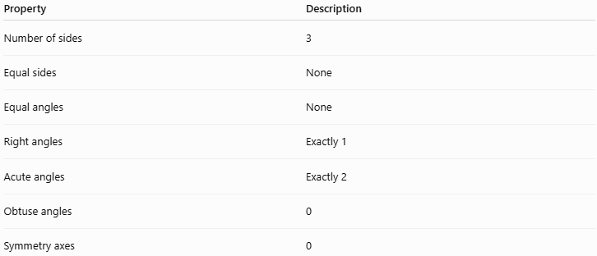
Property | Description
Number of sides | 3
Equal sides | None
Equal angles | None
Right angles | Exactly 1
Acute angles | Exactly 2
Obtuse angles | 0
Symmetry axes | 0

Angle Structure
# Source: AI Source: Provided by: [Data Path: Persons Table -> ID Column: 1, Name_En Column: Motasem Essam] -> From: [ChatGPT] on [7/25/2026]
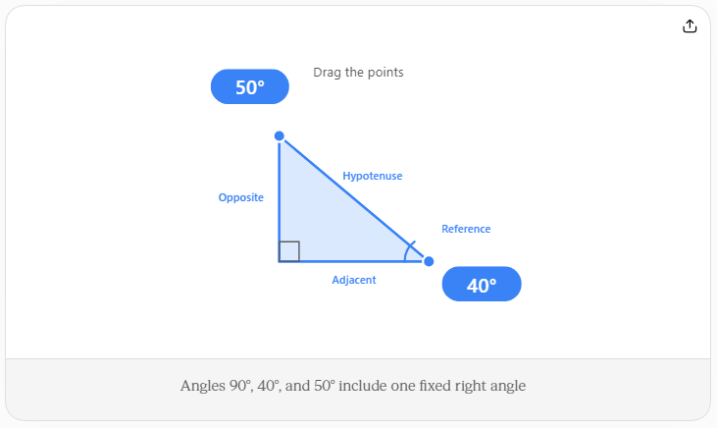
A scalene right triangle contains:
$$\boxed{{90}^{∘}, α, β}$$
where
$$\boxed{α+β={90}^{∘}}$$
and, because it is scalene,
$$\boxed{α≠β}$$
Thus, unlike an isosceles right triangle, the two acute angles are not both ${45}^{∘}$.

Pythagorean Theorem
# Source: AI Source: Provided by: [Data Path: Persons Table -> ID Column: 1, Name_En Column: Motasem Essam] -> From: [ChatGPT] on [7/25/2026]
If the legs are $a$and $b$, and the hypotenuse is $c$:
$$\boxed{a^{2}+b^{2}=c^{2}}$$
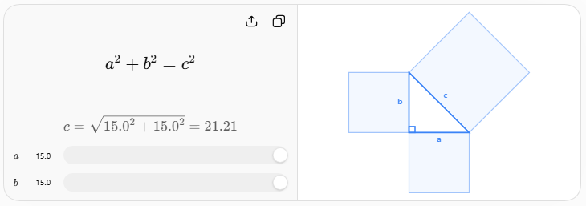
Since the triangle is scalene:
$$\boxed{a≠b}$$
and therefore it is not an isosceles right triangle.
The hypotenuse satisfies:
$$\boxed{c>a}$$
and
$$\boxed{c>b}$$

Converse of the Pythagorean Theorem
# Source: AI Source: Provided by: [Data Path: Persons Table -> ID Column: 1, Name_En Column: Motasem Essam] -> From: [ChatGPT] on [7/25/2026]
For three positive side lengths $a,b,c$, where $c$is the longest side:
$$\boxed{a^{2}+b^{2}=c^{2}}$$
proves that the triangle is right.
If the three sides are also different, it is specifically a scalene right triangle.

Common Example: 3–4–5 Triangle
# Source: AI Source: Provided by: [Data Path: Persons Table -> ID Column: 1, Name_En Column: Motasem Essam] -> From: [ChatGPT] on [7/25/2026]
One of the most famous scalene right triangles has side lengths:
$$\boxed{3, 4, 5}$$
Check:
$$3^{2}+4^{2}=5^{2} \\ 9+16=25 \\ \boxed{25=25}$$
Therefore, it is a right triangle.
Because:
$$3≠4≠5$$
it is also scalene.
Thus:
$$\boxed{3\text{-}4\text{-}5\text{ is a scalene right triangle}}$$
Its acute angles are approximately:
$$\boxed{{36.87}^{∘}\text{ and }{53.13}^{∘}}$$

Special Pythagorean Triples
# Source: AI Source: Provided by: [Data Path: Persons Table -> ID Column: 1, Name_En Column: Motasem Essam] -> From: [ChatGPT] on [7/25/2026]
Other examples include:
$$\boxed{5, 12, 13}$$
because
$$5^{2}+{12}^{2}={13}^{2}$$
and
$$\boxed{8, 15, 17}$$
because
$$8^{2}+{15}^{2}={17}^{2}.$$
These are all scalene right triangles.
A Pythagorean triple consists of positive integers satisfying:
$$\boxed{a^{2}+b^{2}=c^{2}}$$
Most primitive Pythagorean triples produce scalene right triangles.

Side–Angle Relationship
# Source: AI Source: Provided by: [Data Path: Persons Table -> ID Column: 1, Name_En Column: Motasem Essam] -> From: [ChatGPT] on [7/25/2026]
The largest side is always opposite the largest angle.
Since the right angle is the largest angle:
$$\boxed{\text{Hypotenuse = longest side}}$$
The two legs correspond to the two acute angles.
If:
$$a<b<c$$
then the opposite angles satisfy:
$$\boxed{∠A<∠B<∠C={90}^{∘}}$$

Area
# Source: AI Source: Provided by: [Data Path: Persons Table -> ID Column: 1, Name_En Column: Motasem Essam] -> From: [ChatGPT] on [7/25/2026]
The two legs serve naturally as the base and height.
Therefore:
$$\boxed{A=\frac{1}{2}ab}$$
For example, for a $3$-$4$-$5$ triangle:
$$A=\frac{1}{2}\left(3\right)\left(4\right) \\ \boxed{A=6}$$

Perimeter
# Source: AI Source: Provided by: [Data Path: Persons Table -> ID Column: 1, Name_En Column: Motasem Essam] -> From: [ChatGPT] on [7/25/2026]
The perimeter is:
$$\boxed{P=a+b+c}$$
For a $3$-$4$-$5$ triangle:
$$P=3+4+5 \\ \boxed{P=12}$$

Altitudes
# Source: AI Source: Provided by: [Data Path: Persons Table -> ID Column: 1, Name_En Column: Motasem Essam] -> From: [ChatGPT] on [7/25/2026]
A right triangle has three altitudes.
The two legs themselves are altitudes relative to each other:
$$\boxed{a⊥b}$$
The third altitude extends from the right-angle vertex to the hypotenuse.
If the hypotenuse is $c$, the altitude to the hypotenuse is:
$$\boxed{h_{c}=\frac{ab}{c}}$$
For a $3$-$4$-$5$ triangle:
$$h_{c}=\frac{3\left(4\right)}{5} \\ \boxed{h_{c}=\frac{12}{5}=2.4}$$

Triangle Centers
# Source: AI Source: Provided by: [Data Path: Persons Table -> ID Column: 1, Name_En Column: Motasem Essam] -> From: [ChatGPT] on [7/25/2026]
A scalene right triangle has the following center positions:
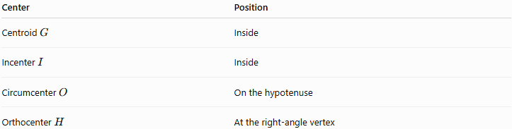
Center | Position
Centroid $G$ | Inside
Incenter $I$ | Inside
Circumcenter $O$ | On the hypotenuse
Orthocenter $H$ | At the right-angle vertex
This is a particularly important property of right triangles.
Circumcenter
The circumcenter is the midpoint of the hypotenuse:
$$\boxed{O=\text{midpoint of hypotenuse}}$$
Therefore, the circumradius is:
$$\boxed{R=\frac{c}{2}}$$
Orthocenter
The orthocenter is exactly the vertex containing the right angle:
$$\boxed{H=C}$$
if
$$∠C={90}^{∘}.$$

Euler Line
# Source: AI Source: Provided by: [Data Path: Persons Table -> ID Column: 1, Name_En Column: Motasem Essam] -> From: [ChatGPT] on [7/25/2026]
For a scalene right triangle:
$$\boxed{O, G, H\text{ are collinear}}$$
and
$$\boxed{OG:GH=1:2}$$
The Euler line passes through:
- the circumcenter $O$,
- the centroid $G$,
- the orthocenter $H$.
Unlike an isosceles right triangle, it does not coincide with a symmetry axis because a scalene triangle has no symmetry axis.

Incenter
# Source: AI Source: Provided by: [Data Path: Persons Table -> ID Column: 1, Name_En Column: Motasem Essam] -> From: [ChatGPT] on [7/25/2026]
The incenter $I$is the intersection of the three internal angle bisectors.
For a right triangle with legs $a,b$and hypotenuse $c$, the inradius is:
$$\boxed{r=\frac{a+b-c}{2}}$$
For a $3$-$4$-$5$ triangle:
$$r=\frac{3+4-5}{2} \\ \boxed{r=1}$$

No Line of Symmetry
# Source: AI Source: Provided by: [Data Path: Persons Table -> ID Column: 1, Name_En Column: Motasem Essam] -> From: [ChatGPT] on [7/25/2026]
A scalene triangle has no pair of equal sides.
Therefore:
$$\boxed{\text{Number of symmetry axes}=0}$$
This distinguishes it from an isosceles right triangle, which has one symmetry axis.

Coordinate Representation
# Source: AI Source: Provided by: [Data Path: Persons Table -> ID Column: 1, Name_En Column: Motasem Essam] -> From: [ChatGPT] on [7/25/2026]
A scalene right triangle can be represented with its right-angle vertex at the origin.
For example:
$$A=\left(0 , 0\right) \\ B=\left(3 , 0\right) \\ C=\left(0 , 4\right)$$
Then:
$$AB=3 \\ AC=4$$
and:
$$BC=5.$$
Therefore:
$$\boxed{△ABC\text{ is a scalene right triangle}}$$
The right angle occurs at $A$:
$$\boxed{∠A={90}^{∘}}$$

Comparison with Isosceles Right Triangle
# Source: AI Source: Provided by: [Data Path: Persons Table -> ID Column: 1, Name_En Column: Motasem Essam] -> From: [ChatGPT] on [7/25/2026]
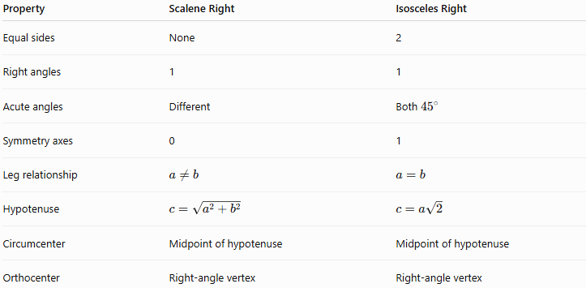
Property | Scalene Right | Isosceles Right
Equal sides | None | 2
Right angles | 1 | 1
Acute angles | Different | Both ${45}^{∘}$
Symmetry axes | 0 | 1
Leg relationship | $$a≠b$$ | $$a=b$$
Hypotenuse | $$c=\sqrt{a^{2}+b^{2}}$$ | $$c=a\sqrt{2}$$
Circumcenter | Midpoint of hypotenuse | Midpoint of hypotenuse
Orthocenter | Right-angle vertex | Right-angle vertex

Real-World Applications
# Source: AI Source: Provided by: [Data Path: Persons Table -> ID Column: 1, Name_En Column: Motasem Essam] -> From: [ChatGPT] on [7/25/2026]
Scalene right triangles are used in:
- Land surveying
- Construction
- Architecture
- Engineering
- Navigation
- Distance calculations
- Computer graphics
- Coordinate geometry
- Roof and stair design
- Measuring inaccessible distances
The $3$-$4$-$5$ triangle is particularly useful for checking whether an angle is exactly ${90}^{∘}$in practical construction.

Key Points
# Source: AI Source: Provided by: [Data Path: Persons Table -> ID Column: 1, Name_En Column: Motasem Essam] -> From: [ChatGPT] on [7/25/2026]
- A Scalene Right Triangle has three unequal sides.
- It has exactly one ${90}^{∘}$angle.
- Its other two angles are acute and unequal.
- Its hypotenuse is the longest side.
- The legs are perpendicular:
$$\boxed{a⊥b}$$
- It satisfies the Pythagorean theorem:
$$\boxed{a^{2}+b^{2}=c^{2}}$$
- It has no line of symmetry.
- Its circumcenter is the midpoint of the hypotenuse.
- Its orthocenter is the right-angle vertex.
- Its centroid and incenter are inside the triangle.
- Its Euler line passes through $O$, $G$, and $H$.

Conclusion
# Source: AI Source: Provided by: [Data Path: Persons Table -> ID Column: 1, Name_En Column: Motasem Essam] -> From: [ChatGPT] on [7/25/2026]
A Scalene Right Triangle combines the classifications scalene by sides and right by angles. It has three unequal sides, one ${90}^{∘}$angle, and two different acute angles. The Pythagorean theorem provides its fundamental side relationship, while its circumcenter and orthocenter have especially simple positions: the circumcenter is the midpoint of the hypotenuse and the orthocenter is the right-angle vertex.

